# Electric Vehicle Landscape Analysis Dashboard

## Washington State EV Market Intelligence Project

### Project Overview

This comprehensive data analysis project examines the electric vehicle (EV) landscape in Washington State, providing actionable insights into market trends, geographic distribution, and key performance indicators. The dashboard serves as a strategic tool for understanding EV adoption patterns, manufacturer market share, and infrastructure implications across the state.

### Technical Implementation

#### Data Processing & Analytics

* **SQL Data Cleaning:** Implemented robust data cleaning procedures using SQL to ensure data quality and consistency
* **KPI Development:** Designed and executed complex SQL queries to calculate key performance indicators including:
  + Total EV units and growth trends
  + Average vehicle range analysis
  + CAFV (Clean Alternative Fuel Vehicle) eligibility rates
  + Geographic distribution metrics
  + Market share calculations

#### Visualization & Dashboard Development

* **Power BI Implementation:** Developed an interactive dashboard using Power BI with advanced visualizations
* **Multi-dimensional Analysis:** Created comprehensive views across temporal, geographic, and categorical dimensions
* **User Experience Design:** Implemented intuitive filtering capabilities for year, county, make, and model selections

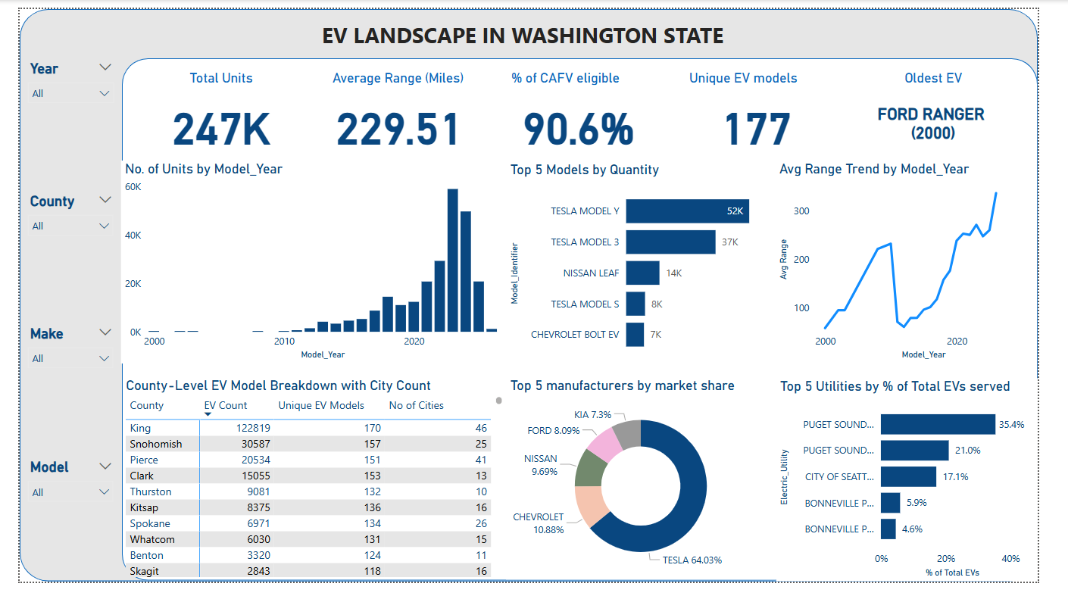

### Key Insights & Findings

#### Market Overview

* **Total EV Units:** 247,000 electric vehicles registered in Washington State
* **Average Range:** 229.51 miles across all EV models
* **CAFV Eligibility:** 90.6% of vehicles qualify for clean alternative fuel incentives
* **Model Diversity:** 177 unique EV models available in the market
* **Historical Context:** Ford Ranger (2000) identified as the oldest EV model in the dataset

#### Geographic Distribution

* **King County Leadership:** Dominates with 122,819 EVs (49.7% of state total)
* **Urban Concentration:** Top counties (King, Snohomish, Pierce) account for majority of EV adoption
* **Rural Penetration:** Significant opportunities identified in smaller counties for market expansion

#### Market Dynamics

* **Tesla Dominance:** Commands 64.03% market share, with Model Y (52K units) and Model 3 (37K units) leading
* **Diverse Competition:** Nissan (9.69%), Chevrolet (10.88%), and Ford (8.09%) provide competitive alternatives
* **Growth Trajectory:** Exponential growth pattern from 2000-2023, with acceleration post-2015

#### Infrastructure Insights

* **Utility Coverage:** Puget Sound utilities serve 56.5% of EVs, indicating concentrated charging infrastructure needs
* **Range Evolution:** Average range increased from ~100 miles (2010) to over 300 miles (2023), addressing range anxiety

### Technical Skills Demonstrated

#### Database Management

* Advanced SQL querying for data extraction and transformation
* Complex joins and aggregations for multi-table analysis
* Data quality assurance and validation procedures
* Performance optimization for large datasets

#### Business Intelligence

* Power BI dashboard development with interactive visualizations
* DAX calculations for advanced metrics
* Geographic mapping and spatial analysis
* Time series analysis and trending

#### Data Analysis

* Statistical analysis of EV adoption patterns
* Market segmentation and competitive analysis
* Trend identification and forecasting insights
* KPI development and performance measurement

### Business Value & Applications

#### Strategic Planning

* **Market Entry Analysis:** Identifies high-opportunity counties for EV infrastructure investment
* **Competitive Intelligence:** Provides manufacturer market share insights for strategic positioning
* **Policy Support:** Informs clean energy policy decisions with adoption metrics

#### Operational Insights

* **Infrastructure Planning:** Guides charging station deployment based on geographic EV density
* **Inventory Management:** Supports dealership inventory decisions with model popularity data
* **Utility Planning:** Assists utility companies in grid capacity planning for EV charging demands

### Project Outcomes

* Created a comprehensive, interactive dashboard enabling data-driven decision making
* Identified key market trends and growth opportunities in the Washington EV market
* Developed scalable analytical framework applicable to other states or regions
* Demonstrated proficiency in end-to-end data analysis workflow from raw data to business insights

### Tools & Technologies

* **Database:** SQL Server for data processing and analysis
* **Visualization:** Microsoft Power BI for dashboard development
* **Data Sources:** Washington State EV registration data from Data.gov
* **Analytics:** Statistical analysis and time series forecasting